**ADVANCED PROGRAMMING**

S. Abhishek

AM. EN. U4CSE19147

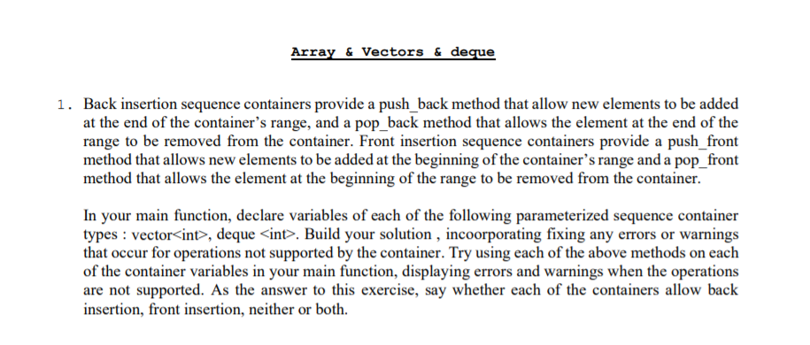

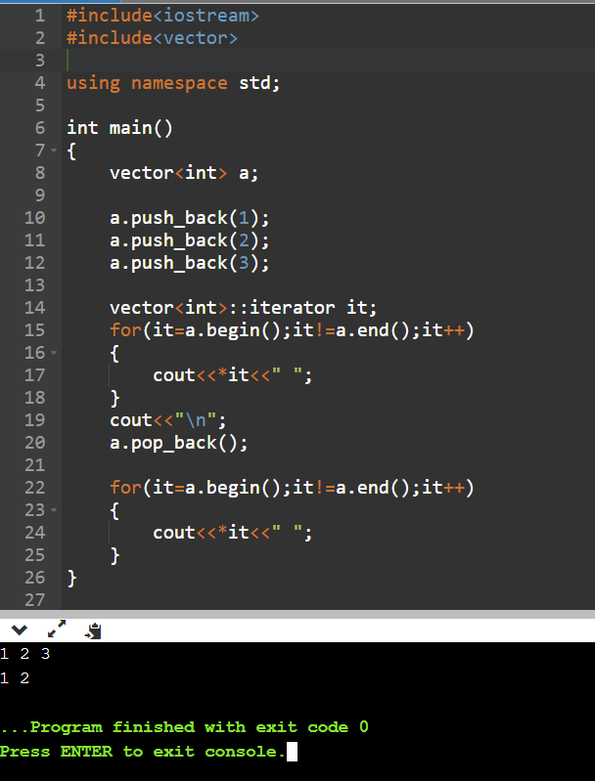

Vector supports only “push_back()” and “pop_back()”;

It doesn’t support “push_front()” and “pop_front()”.

Vector elements are placed in contiguous storage so that they can be accessed and traversed using iterators.

In vectors, data is inserted at the end.

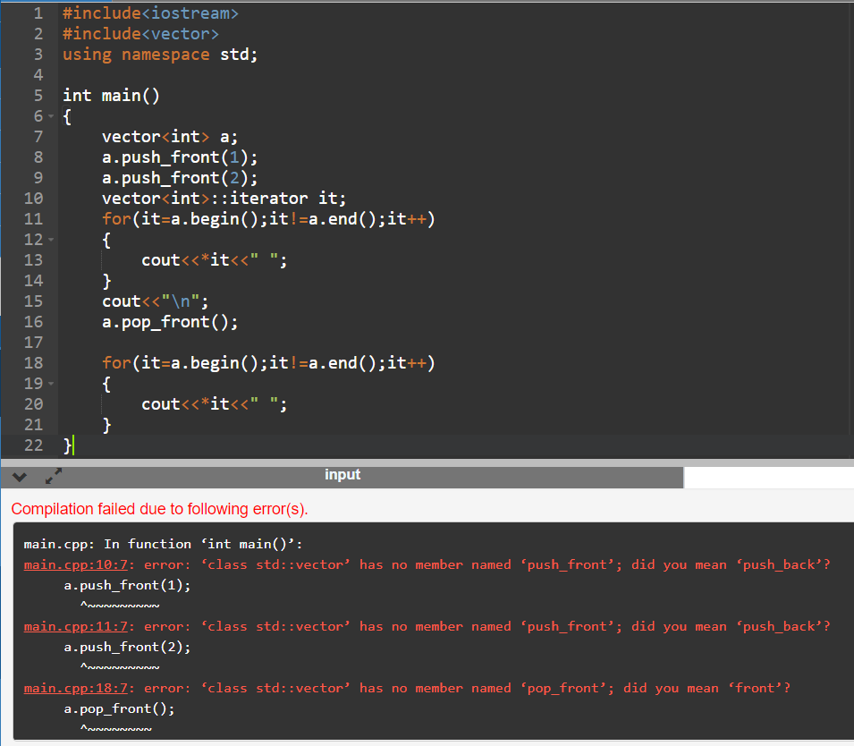

Double ended queues are sequence containers with the feature of expansion and contraction on both the ends.

They are similar to vectors, but are more efficient in case of insertion and deletion of elements.

Double ended queues are a special case of queues where insertion and deletion operations are possible at both the ends.

The functions for deque are same as [vector](http://quiz.geeksforgeeks.org/vector-sequence-containers-the-c-standard-template-library-stl-set-1), with an addition of push and pop operations for both front and back.

